***Bases:***

USSSA

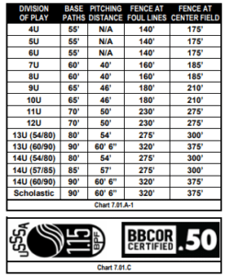

Brandon Valley/Yankton/Sioux Falls

8U & 9u & 10u – 46’ Pitching Rubber and 60’ bases. 2. 11u & 12u – 50’ pitching rubber and 70’ bases.

***Pitching:***

USSSA

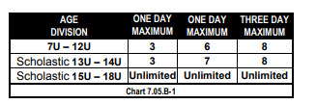

Brandon Valley/Yankton/Sioux Falls

All Divisions – Six innings for the tournament. You can distribute these innings however you

like if your team doesn’t exceed six innings for a pitcher. (One pitch = One inning.)

***Bats:***

USSSA

**Big Barrel Bat Rules (2⅝” or 2¾”) – 14U & Below**

Have the new permanent(2) USSSA Mark on its taper OR

Be a Qualified BBCOR bat(1) OR

Be a Wood Bat

ALL of the above must be manufactured by an approved USSSA Bat Licensee

This applies to ALL Big Barrel Bats, including Coach Pitch bats.

**Small Barrel Baseball Bat Rules (2¼” or less)**

Have the new permanent(2) USSSA mark on its taper(3) OR

Be a Wood Bat

Both of the above must be manufactured by an approved USSSA Bat Licensee

Brandon Valley/Yankton/Sioux Falls

USA STAMPED BATS (NO DROP LIMITS) and WOOD BATS ARE ALLOWED. NO USSSA BATS

ARE ALLOWED.

***Base Running:***

USSSA

1. 7u and 8u – No leading off, stealing is allowed once the ball crosses home plate.
2. 9U and up – Normal baseball rules

Brandon Valley/Yankton/Sioux Falls

1. 9u and 10u – Stealing is allowed once the ball crosses home plate. Home plate is closed on a

play that start with a steal attempt. Players can only score from third base on a batted ball or

when forced home by a walk or hit by pitch. The NHFS dropped third strike rule is not active.

All dropped third strikes the batter is out.

1. 11u – Stealing is allowed once the ball leaves the pitcher’s hand. Home plate is open. The

dropped 3rd strike is NFHS rules – active.

1. 12u – Leading off is allowed. Home plate is open. The dropped 3rd strike is NFHS rules –

active.